R

# MAULANA ABUL KALAM AZAD UNIVERSITY OF TECHNOLOGY, WEST BENGAL

**(Formerly known as West Bengal University of Technology)**



**PROVISIONAL GRADE CARD**

|  |  |
| --- | --- |
| **THIRD YEAR B.Tech. (CSE) SECOND SEMESTER EXAMINATION OF 2023-24** | |
| **NAME : ARPAN KUMAR SINGH** | **ROLL NO. : 13000120041** |
| **REGISTRATION NO : 201300100110084 OF 2020-21** | |
| **PROGRAM: BACHELOR OF TECHNOLOGY IN COMPUTER SCIENCE & ENGINEERING** | |
| **COLLEGE / INSTITUTION: 130-TECHNO MAIN SALT LAKE (FORMERLY, TECHNO INDIA)** | |

|  |  |  |  |  |  |
| --- | --- | --- | --- | --- | --- |
| **Subject Code** | **Subjects Offered** | **Letter**  **Grade** | **Points** | **Credit** | **Credit**  **Points** |
| PCC-CS601 | Database Management Systems | A | 8 | 3.0 | 24 |
| PCC-CS602 | Computer Networks | B | 7 | 3.0 | 21 |
| PEC-IT601B | Distributed Systems | A | 8 | 3.0 | 24 |
| PEC-IT602D | Pattern Recognition | A | 8 | 3.0 | 24 |
| OEC-IT601A | Numerical Methods | A | 8 | 3.0 | 24 |
| PROJ-CS601 | Research Methodology | E | 9 | 3.0 | 27 |
| PCC-CS691 | Database Management Systems | B | 7 | 2.0 | 14 |
| PCC-CS692 | Computer Networks | A | 8 | 2.0 | 16 |
|  |  |  | **Total** | **22** | **174** |

|  |  |
| --- | --- |
| **SGPA EVEN. (6th) SEMESTER : 7.90** |  |
| **RESULT EVEN. (6th) SEMESTER : P** |  |

*Please report of any discrepancy through college within 7 days,*

*Otherwise, University will not responsible for any errors in transcripts (if any)*

.

**Kolkata**

**14-08-2024**

Printed On: 14-08-2024 20:00:53

1. The table below shows the Letter Grades and their corresponding classification and percentage points

|  |  |  |  |
| --- | --- | --- | --- |
| **Classification** | **Letter Grade** | **Score on 100 Percentage Points** | **Points** |
| Outstanding | O | 100 to 90 | 10 |
| Excellent | E | 89 to 80 | 9 |
| Very Good | A | 79 to 70 | 8 |
| Good | B | 69 to 60 | 7 |
| Fair | C | 59 to 50 | 6 |
| Below Average | D | 49 to 40 | 5 |
| Failed | F | Below 40 | 2 |
| Incomplete | I | --- | 2 |

1. No Class / Percentage is awarded

1. Result Status: X=Not eligible for Semester Promotion/Degree; XP=Eligible for Promotion with Backlogs; P=Passed and Promoted

4.The method of calculation of Grade Point Average is as follows

**SGPA** Credit Index

=

## (Semester Grade Point Average) Credits

**YGPA** Credit Index Odd Semester + Credit Index Even Semester =

## (Yearly Grade Point Average) Credits Odd Semester + Credits Even Semester

1. For final Degree Grade Point Average (DGPA) the calculation is as under

|  |  |  |
| --- | --- | --- |
| **DGPA**  (For 4 Year Degree Course) | = | YGPA 1 + YGPA2 + 1.5* YGPA3 + 1.5* YGPA4  5 |
| **DGPA**  (For Lateral Entry Students) | = | YGPA2 + 1.5* YGPA3 + 1.5* YGPA4  4 |
| **DGPA**  (For 3 Year Degree Course) | = | YGPA 1 + YGPA2 + YGPA3  3 |
| **DGPA**  (For 2 Year Degree Course) | = | YGPA 1 + YGPA2 2 |
| **DGPA**  (For 1 Year Degree Course) | = | YGPA 1 |

1. CUMULATIVE GRADE POINT AVERAGE (CGPA)

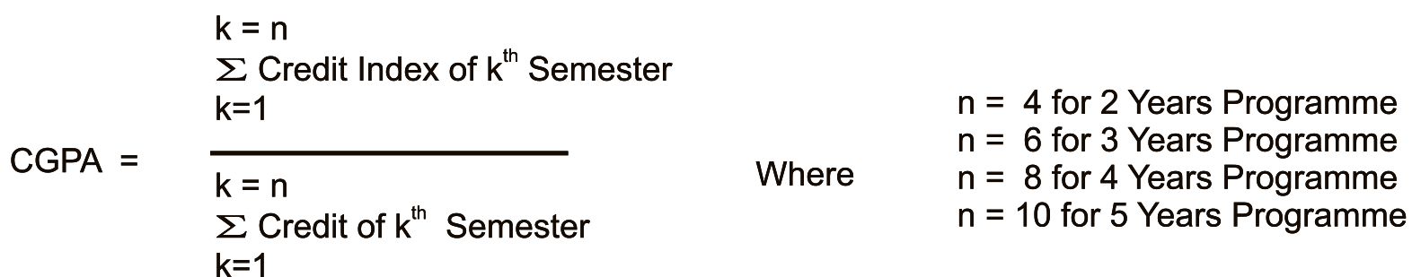

Printed On: 16-07-2024 23:20:53